DNA Certification Examination Grant Application
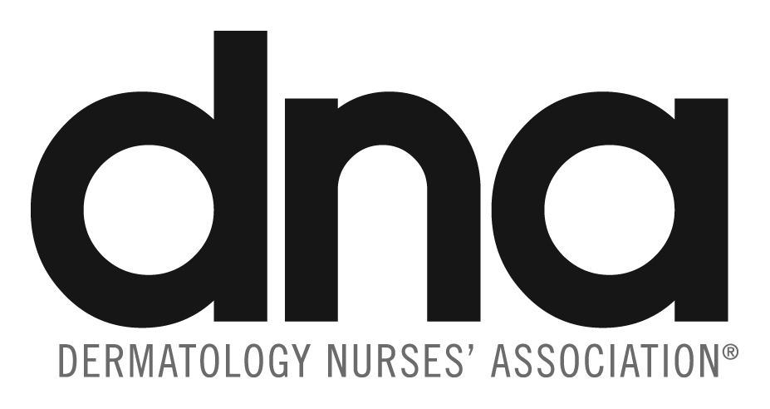

Date: _________________

Nominee: _________________________________________________________________

Address: __________________________________________________________________

Phone: (H) _________________________ (W) __________________________

Email: ___________________________________________

State of License: ____________ License Number: ________________

Instructions: Please fill out questions 1–7 on this DNA Certification Examination Grant Application Form for demographic information purposes only. Your responses will be used for demographic purposes only. Grants are based on the quality and content of your essay.
Your one completed essay answering all three questions below should be attached as a separate document from the application form. It should contain 1200 words or less, use 12pt font, and sentences be double spaced.

Applying for: DNC Certification Grant DNPC Certification Grant

Three Questions in ONE essay:

- What motivated you to become certified?

- How will certification enhance and impact your current nursing practice?

- Discuss what financial barriers you may have.

Demographic Questions:

1. Education (document all degrees/diplomas)

2. Certification:
- Dermatology Nursing:
- Other Nursing:
- Other:

3. Years Active DNA Membership:
- Current, consecutive, and complete 2 years
- 2-4 years
- 5-9 years
- 10+ years

4. Dermatology Experience:
- 2-4 years
- 5-9 years
- 10+ years

5. Professional Associations (Within last 3 years):
- DNA National:
~ DNA National Elected Office
~ Committee Chair
~ JDNA Board or author
~ DNA Convention speaker
~ Committee Member
~ JDNA Reviewer
~ Convention Moderator
~ Other Organizational National Office
- DNA Local Chapter:
~ Officer/Committee Chair
~ Other
- Membership in professional organizations other than DNA:
~ Examples: ANA, AANP, AANC, WOCN
~ State Nurses’ Association
~ Other: Leadership roles; Advocacy efforts

6. Professional Volunteer Activities for the last 3 years: (no more than 3 examples)
- Skin cancer screenings:
- Health fair and/or Community Health events
- Dermatology or other health camps:
- Committee/leadership activities in work setting

7. What DNA Volunteer opportunities would you like to pursue?

APPLICATION MATERIALS MUST BE SUBMITTED AS SINGLE SIDED PAPER ONLY

Applications must be postmarked on or before October 1 preceding the year you intend to take the exam.

Return application to:
DNA Awards/Scholarships
435 N. Bennett Street
Southern Pines, NC 28387
Email: dna@dnanurse.org
FAX: 910-246-2361

Revised 11/2024

